To handle multiple users booking the same ticket concurrently in .NET Core and SQL, you must implement concurrency control mechanisms at the database level. The two primary approaches are Optimistic Concurrency Control (OCC) and Pessimistic Concurrency Control.
1. Optimistic Concurrency Control (Recommended for High Traffic)
This approach assumes conflicts are rare and allows transactions to proceed without locks, checking for conflicts only upon saving changes. It generally offers better performance and scalability in read-heavy scenarios like ticket booking.
Implementation Steps:
- Add a Concurrency Token to the SQL Table:
Add a column to your Tickets or Seats table to act as a version identifier. In SQL Server, the rowversion (timestamp) data type is ideal as the database automatically manages its value.
sql
ALTER TABLE Seats ADD Version ROWVERSION;
Use code with caution.
- Configure Entity Framework Core (EF Core) Entity:
In your .NET Core application, map this column in your entity configuration to treat it as a concurrency token.
csharp
public class Seat
{
public int Id { get; set; }
public string SeatNumber { get; set; }
public bool IsBooked { get; set; }
public string? BookedByUserId { get; set; }

[Timestamp] // Data annotation
public byte[] Version { get; set; } // Map to rowversion in SQL Server
}
Use code with caution.

- Handle the Conflict in C# Code:
When a user attempts to book a seat, retrieve the current seat record including its version number. When saving changes, EF Core will include the original Version in the UPDATE statement's WHERE clause. If another user has booked the seat in the meantime, the UPDATE will affect zero rows, and EF Core will throw a DbUpdateConcurrencyException. 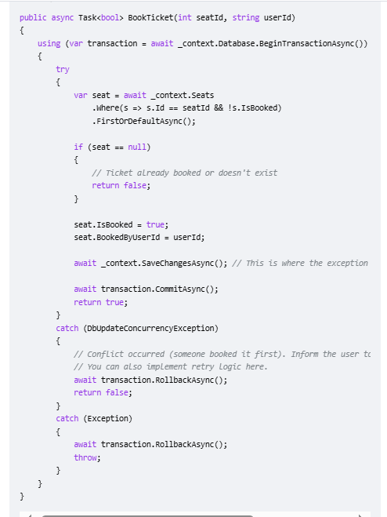

2. Pessimistic Concurrency Control (Locking)
This approach assumes conflicts are likely and prevents them by locking the data before it is read or updated. This is ideal for high-contention scenarios but can lead to performance issues or deadlocks if not managed carefully.
Implementation Steps:
You can use a database transaction with a stricter isolation level or a locking hint in your SQL query.
- Use Higher Isolation Levels with EF Core:
You can elevate the transaction isolation level to SERIALIZABLE or REPEATABLE READ in .NET Core.
csharp
using System.Data;
// ...
public async Task<bool> BookTicketPessimistic(int seatId, string userId)
{
// Use a Serializable transaction to lock the range of data being read/written
using (var transaction = await _context.Database.BeginTransactionAsync(IsolationLevel.Serializable))
{
try
{
// This read operation will now acquire a lock based on the isolation level
var seat = await _context.Seats
.Where(s => s.Id == seatId && !s.IsBooked)
.FirstOrDefaultAsync();

if (seat == null)
{
await transaction.RollbackAsync();
return false;
}

seat.IsBooked = true;
seat.BookedByUserId = userId;

await _context.SaveChangesAsync();
await transaction.CommitAsync();
return true;
}
catch (Exception)
{
// Handle potential deadlocks if using serializable isolation level
await transaction.RollbackAsync();
throw;
}
}
}
Use code with caution.
- Use SQL Locking Hints (More Complex):
For finer control and potentially better performance, you can use raw SQL queries with hints like UPDLOCK (ensure to apply on the SELECT query). This is more complex to integrate seamlessly with EF Core's change tracking.
Key Considerations
- User Experience: With optimistic concurrency, the second user is quickly notified that the seat is no longer available. With pessimistic locking, the second user's request might hang while waiting for the lock to be released, which could result in a timeout.
- Scalability: Optimistic concurrency scales better across multiple application instances in a distributed system, as it avoids maintaining persistent locks.
- Idempotency: Consider implementing idempotency tokens at the application layer to prevent duplicate requests if a user double-clicks a submit button.
For most high-volume booking systems, Optimistic Concurrency Control is the preferred approach.

SQL Deadlock:
Preventing deadlocks using code primarily involves two strategies: writing Transact-SQL (T-SQL) with a consistent access pattern and using application-side retry logic to automatically restart a transaction that the database has chosen as a deadlock victim.
T-SQL Code for Prevention
You can minimize deadlocks by ensuring a consistent order of operations and, in some cases, setting deadlock priority within your SQL code itself.
- Consistent Object Access Order: Always access tables (and rows within them) in the same logical order across all your transactions.
sql
-- Session 1
BEGIN TRANSACTION;
UPDATE TableA SET Value = 1 WHERE Id = 1;
-- Other operations...
UPDATE TableB SET Value = 1 WHERE Id = 1;
COMMIT TRANSACTION;

-- Session 2 must follow the same order to prevent deadlocks:
BEGIN TRANSACTION;
UPDATE TableA SET Value = 2 WHERE Id = 1;
-- Other operations...
UPDATE TableB SET Value = 2 WHERE Id = 1;
COMMIT TRANSACTION;
Use code with caution.
- Setting Deadlock Priority: You can influence which transaction becomes the victim in a deadlock scenario. The one with the lowest priority will be terminated. The default is NORMAL (0).
sql
-- Set the current connection's transaction priority to Low
SET DEADLOCK_PRIORITY LOW;
BEGIN TRANSACTION;
-- Your transaction logic here
COMMIT TRANSACTION;
Use code with caution.
- T-SQL Retry Logic: You can embed simple retry logic directly into stored procedures using TRY...CATCH and a WHILE loop.
sql
DECLARE @MaxRetries INT = 3;
DECLARE @TryCount INT = 0;

WHILE (@TryCount < @MaxRetries)
BEGIN
SET @TryCount = @TryCount + 1;

BEGIN TRY
-- Start your transaction
BEGIN TRANSACTION;

-- Your UPDATE, INSERT, DELETE statements here
-- Example:
UPDATE Products SET Quantity = Quantity - 1 WHERE ProductId = 1;

COMMIT TRANSACTION;
-- If we reach here, the transaction succeeded, exit the loop
SET @TryCount = @MaxRetries;
END TRY
BEGIN CATCH
IF (ERROR_NUMBER() = 1205) -- 1205 is the SQL Server deadlock error code
BEGIN
ROLLBACK TRANSACTION; -- Rollback the current attempt
-- Optional: Add a small WAITFOR DELAY here to avoid immediate re-deadlock
WAITFOR DELAY '00:00:00.100';
IF (@TryCount >= @MaxRetries)
BEGIN
THROW; -- Rethrow the error if all retries are exhausted
END
-- Otherwise, the loop continues for the next attempt
END
ELSE
BEGIN
-- Handle other errors or rethrow
ROLLBACK TRANSACTION;
THROW;
END
END CATCH
END
Use code with caution.

Application-Level Retry Logic (C# Example)
Implementing retry logic in your application code is generally a more robust approach, as it moves the retry mechanism away from the database server's resources and provides a better user experience.
Here is a C# example using Microsoft.Data.SqlClient that catches the specific deadlock error code (1205) and retries the operation with a short delay.
csharp
using System;
using System.Data.SqlClient;
using System.Threading;

public void ExecuteWithDeadlockRetry(Action transactionAction, int maxRetries = 3)
{
int attempts = 0;
while (attempts < maxRetries)
{
try
{
// The database operation is performed here, often within a 'using (SqlConnection conn = ...)' block
transactionAction.Invoke();
return; // Success, exit the method
}
catch (SqlException ex)
{
if (ex.Number == 1205) // Error 1205 is SQL Server deadlock victim
{
attempts++;
if (attempts >= maxRetries)
{
// Log the final failure
Console.WriteLine($"Deadlock occurred, max retries ({maxRetries}) exceeded. Throwing exception.");
throw;
}
else
{
// Log retry attempt and wait briefly (e.g., exponential backoff)
Console.WriteLine($"Deadlock occurred. Retrying attempt {attempts}/{maxRetries} after a delay.");
// Use a short, randomized delay to prevent immediate re-deadlocking
Thread.Sleep(100 * attempts);
}
}
else
{
// Not a deadlock, throw the exception as normal
throw;
}
}
}
}

// Example usage in your application code:
// ExecuteWithDeadlockRetry(() => {
// // Your ADO.NET or ORM code that runs within a transaction goes here
// // e.g., command.ExecuteNonQuery();
// });
Use code with caution.

Short Answer

How do you handle concurrency conflicts in EF Core?
Scenario: Two users update the same record simultaneously. Answer Approach:
- Use Concurrency Tokens (e.g., RowVersion).
- Example:
C#
modelBuilder.Entity<Product>()
.Property(p => p.RowVersion)
.IsRowVersion();
Show more lines
- Handle DbUpdateConcurrencyException in code.

